**หอในชั้น 1 ระยะ 50 cm**

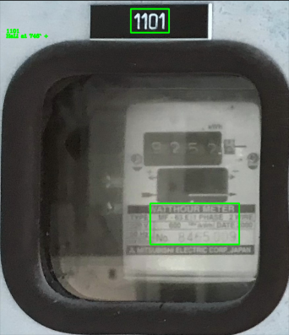D:\Project OCR\Hornai\hornai-50cm-1101.jpg

[[[[396, 28], [512, 28], [512, 100], [396, 100]], '1101'], [[[455, 617], [724, 617], [724, 741], [455, 741]], 'HaLi at 746` +']]

*อ่านไม่ได้เพราะ reflex เยอะ

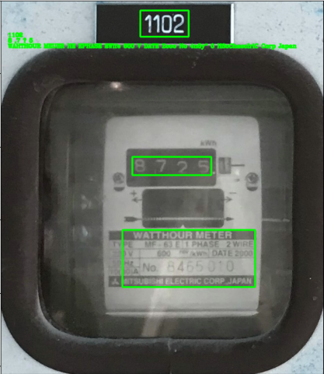

D:\Project OCR\Hornai\hornai-50cm-1102.jpg

[[[[382, 28], [514, 28], [514, 100], [382, 100]], '1102'], [[[360, 428], [576, 428], [576, 478], [360, 478]], '8 ,7 ? 5'], [[[333, 628], [696, 628], [696, 784], [333, 784]], 'WAHTHOUR MEUER HE EPHASE 2Wife600 V DATE Zcoo No 4n5y" 0 HSoChaecIriC Corp Japan']]

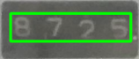

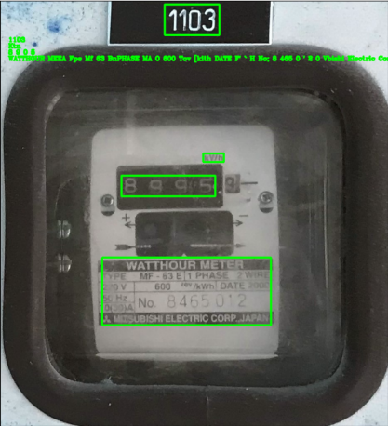D:\Project OCR\Hornai\hornai-50cm-1103.jpg

[[[[396, 10], [528, 10], [528, 84], [396, 84]], '1103'], [[[489, 369], [539, 369], [539, 389], [489, 389]], 'Ktn'], [[[292, 422], [518, 422], [518, 472], [292, 472]], '8 9 0 5'], [[[246, 619], [652, 619], [652, 782], [246, 782]], "WATTHOUR MEEA Fpe Mf 63 BnPHASE MA O 600 Tov [kith DATE F' ` H No; 8 465 0 ' 2 0 Vbishi Electric Corp_ Jaraa"]]

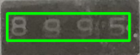

D:\Project OCR\Hornai\hornai-50cm-1104.jpg

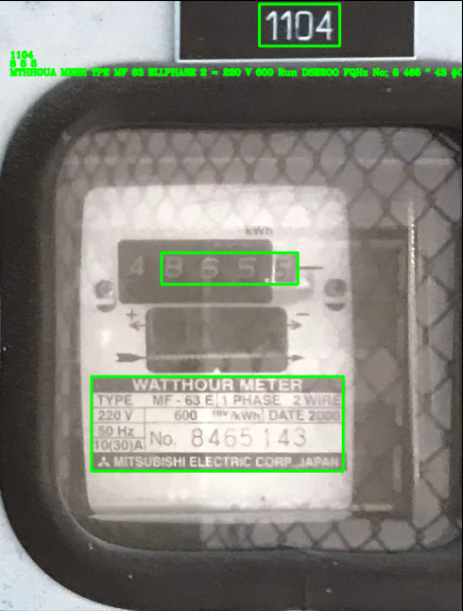[[[[448, 8], [586, 8], [586, 80], [448, 80]], '1104'], [[[280, 434], [514, 434], [514, 488], [280, 488]], '8 5 5 '], [[[160, 646], [592, 646], [592, 808], [160, 808]], 'MTHHOUA MEER TPE MF 63 ELLPHASE 2 = 220 V 600 Run DSE2OO FQHz No; 8 465 " 43 #CJOL Mitsubishi Electac coar']]

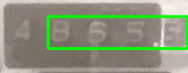

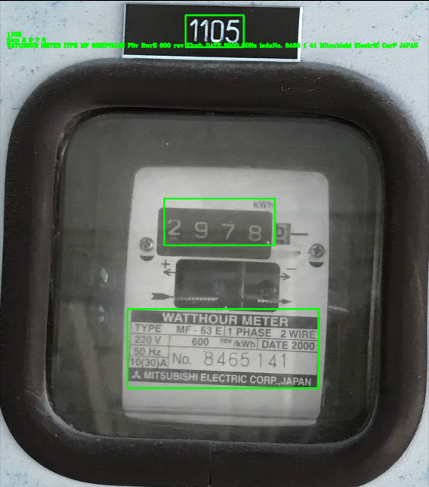

D:\Project OCR\Hornai\hornai-50cm-1105.jpg

[[[[506, 43], [664, 43], [664, 130], [506, 130]], '1105'], [[[448, 541], [749, 541], [749, 668], [448, 668]], 'Kwn 2 9 7 8'], [[[348, 841], [867, 841], [867, 1056], [348, 1056]], 'WATtHOUR METER IYPE MF63ElPHASE F0v RwrE 600 rev Kkwh DATE 2000 50Hz iedaNo. 8465 1 41 Mitsubishi ElectrIC CorP JAPAN']]

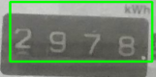

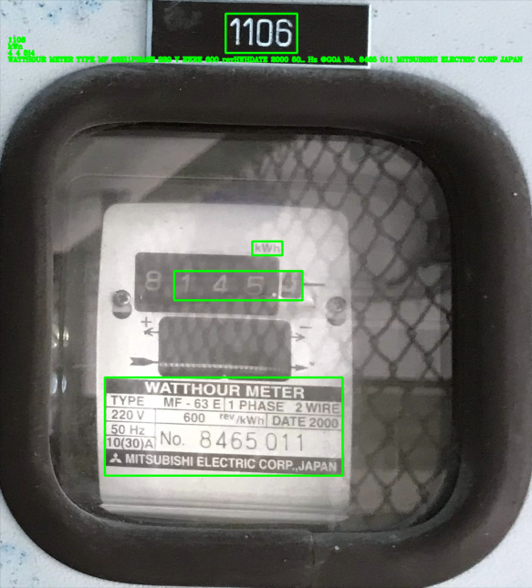D:\Project OCR\Hornai\hornai-50cm-1106.jpg

[[[[519, 35], [683, 35], [683, 125], [519, 125]], '1106'], [[[580, 557], [649, 557], [649, 589], [580, 589]], 'kWn'], [[[401, 625], [695, 625], [695, 692], [401, 692]], '4 4 5j4'], [[[242, 869], [787, 869], [787,1094], [242, 1094]], 'WATTHOUR METER TYPE MF 63El1PHASE 220 V RWRE 600 revHWHDATE 2000 50_ Hz @GOA No. 8465 011 MITSUBISHI ELECTRIC CORP JAPAN']]

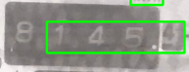

*อ่านค่าพลาด

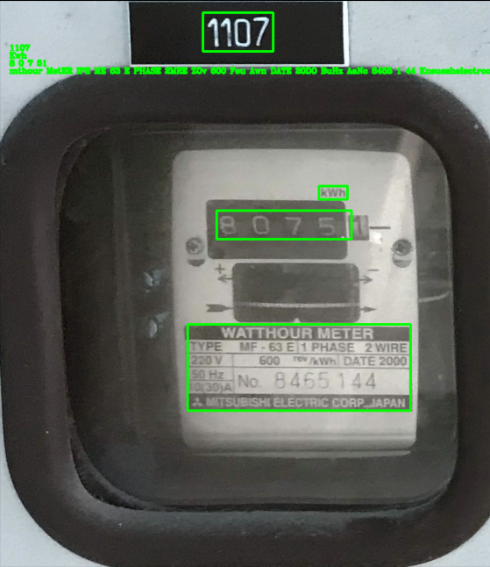

D:\Project OCR\Hornai\hornai-50cm-1107.jpg

[[[[400, 26], [538, 26], [538, 102], [400, 102]], '1107'], [[[628, 366], [684, 366], [684, 392], [628, 392]], 'Kwh'], [[[427, 414], [692, 414], [692, 470], [427, 470]], '8 0 7 51'], [[[370, 637], [808, 637], [808, 806], [370, 806]], 'mthour MetER IPE ME 63 E PHASE 2MRE ZOv 600 Feu Awn DATE 20DO BuHz AaNc 8455 1 44 Knsueshelectrccorp_Japan']]

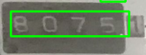

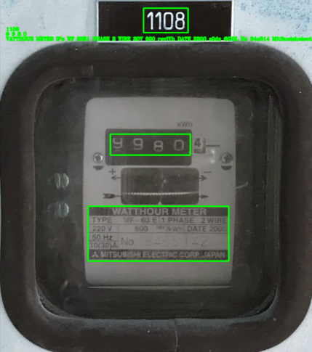D:\Project OCR\Hornai\hornai-50cm-1108.jpg

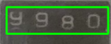[[[[446, 30], [584, 30], [584, 106], [446, 106]], '1108'], [[[343, 421], [591, 421], [591, 486], [343, 486]], '9 9 8 0'], [[[274, 645], [710, 645], [710, 815], [274, 815]], 'VATTHOUR METER IPe WF 63E1 PHASE 2 WIRE 20V 600 reviVh DATE 2200 s0dz @DDL No 34o514 MitSucishelectric corr Japan']]

*จังหวะกำลังเปลี่ยนมิเตอร์แต่อ่านค่าได้ชัดเจน

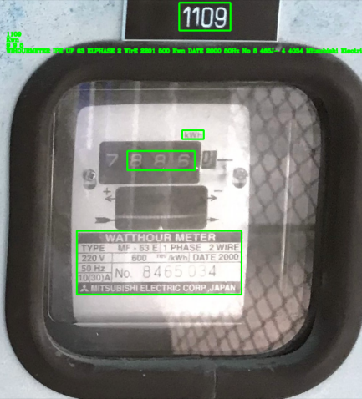

D:\Project OCR\Hornai\hornai-50cm-1109.jpg

[[[[486, 10], [624, 10], [624, 85], [486, 85]], '1109'], [[[494, 354], [552, 354], [552, 378], [494, 378]], 'Kwn'], [[[346, 410], [528, 410], [528, 462], [346, 462]], '9 9 5'], [[[210, 625], [654, 625], [654, 797], [210, 797]], 'WIHOURMETER IPE UF 63 ELPHASE 2 WIrE 2201 500 Kwn DATE 2000 50Hz No 8 465J- 4 4034 Mitsubishi Electric corp Japan']]

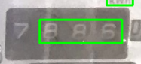

D:\Project OCR\Hornai\hornai-50cm-1110.jpg

[[[[416, 8], [542, 8], [542, 80], [416, 80]], '1110'], [[[450, 382], [506, 382], [506, 406], [450, 406]], 'aa'], [[[252, 432], [352, 432], [352, 484], [252, 484]], '7.5'], [[[178, 646], [553, 646], [553, 818], [178, 818]], 'mHOURMETA IPE I Eleise 220 1 500 Tun Da s0Hz MCANa 8465 " HIISubiShl LLECIAIC corp']]

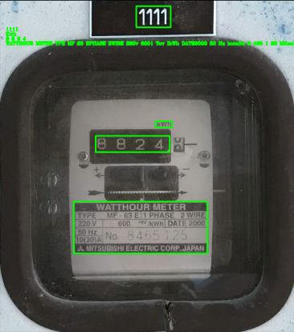D:\Project OCR\Hornai\hornai-50cm-1111.jpg

[[[[437, 21], [547, 21], [547, 89], [437, 89]], '1111'], [[[499, 389], [551, 389], [551, 409], [499, 409]], 'Kwh'], [[[307, 436], [544, 436], [544, 488], [307, 488]], '8 8 2 4'], [[[237, 646], [664, 646], [664, 812], [237, 812]], 'WATTHOUR METER YPE MF 63 EPHASE 2WIRE 220v 6001 Tcv IkWh DATE2000 50 Hz icoaNo 8 465 1 25 Mitsubishi ELectrIC CoRP JAPAN']]

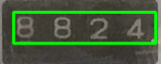

D:\Project OCR\Hornai\hornai-50cm-1112.jpg

[[[[398, 24], [520, 24], [520, 98], [398, 98]], '1112'], [[[583, 385], [633, 385], [633, 405], [583, 405]], 'Rwn'], [[[450, 434], [620, 434], [620, 489], [450, 489]], '2 2 5'], [[[322, 643], [746, 643], [746, 808], [322, 808]], 'MtthouR MEtER IPE f 63ED PHASE EWRE Rz0V 600 MWhIDATE 2000 solz LoNo 8 465 * 28 Unsubishielectric CoapAJAPAN']]

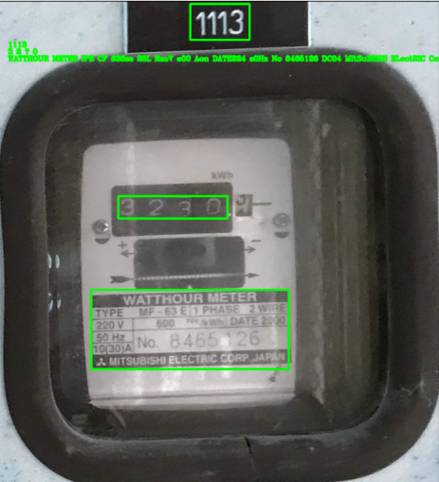

D:\Project OCR\Hornai\hornai-50cm-1113.jpg

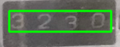[[[[410, 8], [537, 8], [537, 85], [410, 85]], '1113'], [[[256, 420], [490, 420], [490, 468], [256, 468]], '3 2 ? 0'], [[[198, 621], [621, 621], [621, 791], [198, 791]], 'WATTHOUR METER IPE CF 636se 25L RzoV e00 Aon DATE224 s0Hz No 8465126 DC04 MItSuBISHI ELectRIC CorP Jaran']]

*อ่านค่าผิดเพราะกำลังเปลี่ยนมิเตอร์

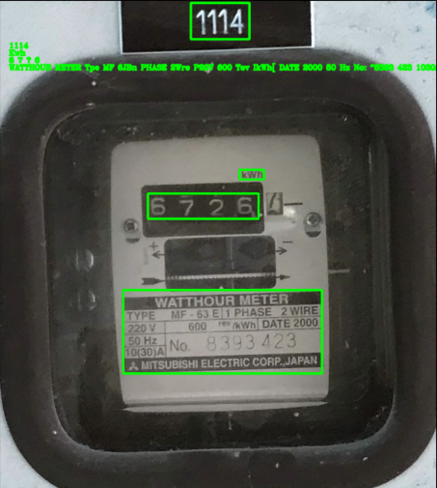

D:\Project OCR\Hornai\hornai-50cm-1114.jpg

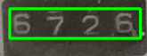[[[[396, 7], [517, 7], [517, 82], [396, 82]], '1114'], [[[497, 351], [547, 351], [547, 371], [497, 371]], 'Kwh'], [[[307, 400], [536, 400], [536, 452], [307, 452]], '6 7 ? 6'], [[[256, 599], [667, 599], [667, 771], [256, 771]], 'WATTHOUR METER Tpe MF 6JBn PHASE 2Wre P20V 600 Tev IkWh[ DATE 2000 50 Hz No: "8393 423 1030A Mitsubishi ElectrIC CorP JAPAN']]

*อ่านค่าผิดเพราะกำลังเปลี่ยนมิเตอร์

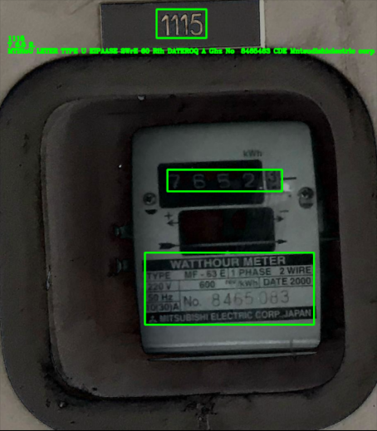

D:\Project OCR\Hornai\hornai-50cm-1115.jpg

[[[[378, 24], [500, 24], [500, 98], [378, 98]], '1115'], [[[458, 406], [686, 406], [686, 462], [458, 462]], '6 5 2.'], [[[351, 613], [757, 613], [757, 779], [351, 779]], 'ITIHOURMETER TfE aF EMPHASE Wre R0 Guo DATE2000 SJhz Nlo; 8465 063 JudOL Mutsudishiclectrig corp JApAN']]

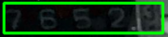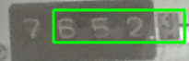

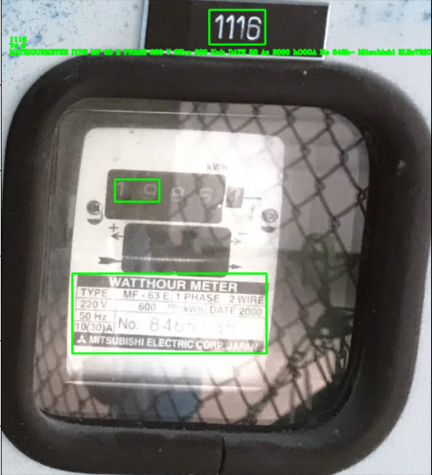 Contrast -90

D:\Project OCR\Hornai\hornai-50cm-1116.jpg

[[[[488, 26], [619, 26], [619, 107], [488, 107]], '1116'], [[[267, 423], [371, 423], [371, 475], [267, 475]], '74 9'], [[[167, 643], [622, 643], [622, 830], [167, 830]], 'MATIHOURMETER IYPE MF 63 E PHASE 220 V 2Wre 600 Kuh DATE 50 Az 2000 hOGOA No 846h^ Mitsubishi ELEcTRICCO5PnT']]

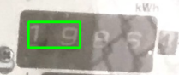

D:\Project OCR\Hornai\hornai-50cm-1117.jpg

[[[[458, 10], [584, 10], [584, 86], [458, 86]], '1117'], [[[555, 356], [612, 356], [612, 384], [555, 384]], 'kWh'], [[[349, 397], [525, 397], [525, 459], [349, 459]], '9 9 3'], [[[264, 619], [712, 619], [712, 806], [264, 806]], 'WATthouR METER IPE QF GEMPHASE 220V 2wirE 600 T MWh[DATE 2000 S0Hz hcoaNo 8465 033 Mnsubishi ElectrIC CorP JAPAN']]

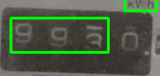

D:\Project OCR\Hornai\hornai-50cm-1118.jpg

[[[[366, 0], [494, 0], [494, 78], [366, 78]], '1118'], [[[616, 366], [674, 366], [674, 390], [616, 390]], 'Kwh'], [[[541, 416], [664, 416], [664, 469], [541, 469]], '8 4'], [[[337, 631], [786, 631], [786, 813], [337, 813]], 'WATTHOUR METER IYPE MF B@nPHASE 2wiae 2z0v 600 e Kkn DATE 2000 soz JOCOA No; 8 465.036 Nitsubishi Electric Corp JAPAN']]

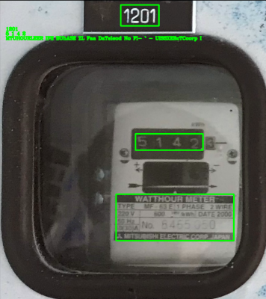**หอในชั้น 2 ระยะ 50 cm**

D:\Project OCR\Hornai\hornai-50cm-1201.jpg

[[[[393, 17], [517, 17], [517, 85], [393, 85]], '1201'], [[[441, 435], [660, 435], [660, 488], [441, 488]], '5 1 4 2'], [[[378, 631], [760, 631], [760, 782], [378, 782]], 'MTUHOURLEER IFE BUhASE ZL Faa DaTeleod No Fi- ` - UISSXERcTCcorp I']]

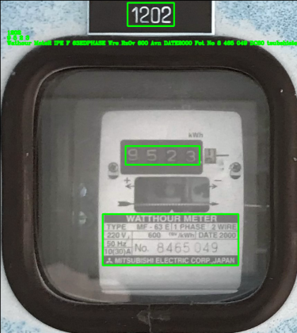D:\Project OCR\Hornai\hornai-50cm-1202.jpg

[[[[368, 9], [502, 9], [502, 76], [368, 76]], '1202'], [[[362, 422], [576, 422], [576, 476], [362, 476]], '9 5 2 3'], [[[296, 618], [688, 618], [688, 766], [296, 766]], 'Wathour MeteR IPE F 63EDPHASE Wre Rz0v 600 Avn DATE2000 Fot No 8 465 049 DC60 tsubshielectric coap_Japan']]

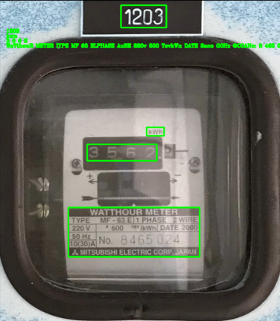D:\Project OCR\Hornai\hornai-50cm-1203.jpg

[[[[369, 17], [507, 17], [507, 85], [369, 85]], '1203'], [[[447, 388], [500, 388], [500, 414], [447, 414]], 'kwn'], [[[266,

440], [478, 440], [478, 490], [266, 490]], '3 5 6 2'], [[[209, 632], [608, 632], [608, 782], [209, 782]], 'WaTthouR METER IYPE MF 63 ELPHASE AuRE 220v 500 TevkWn DATE 2aco G0Hz @COANo: 8 465 024 Mitsubishi ELectrIC CorP JAPAN']]

D:\Project OCR\Hornai\hornai-50cm-1204.jpg

[[[[361, 17], [501, 17], [501, 89], [361, 89]], '1204'], [[[275, 449], [311, 449], [311, 487], [275, 487]], '8'], [[[165, 639], [519, 639], [519, 792], [165, 792]], 'WATHOULETER TYPE MF 63E PHASE = 22V 600 DAE s04z HQANo 0464 306 Mitsubishi ELECtrC corp']]

D:\Project OCR\Hornai\hornai-50cm-1205.jpg

[[[[416, 18], [558, 18], [558, 92], [416, 92]], '1205'], [[[538, 422], [588, 422], [588, 446], [538, 446]], 'kWh'], [[[350, 472], [518, 472], [518, 524], [350, 524]], '4 6 6'], [[[277, 676], [693, 676], [693, 838], [277, 838]], 'WATTHCWR METER TYPE MF 63 BLPHASE 2WRE 220V 600 TCV JWh DATE 2000 SOHz ieoaNo: 8 465 021 MITSUBISHi ELECTRIC CORP_JAPAN']]

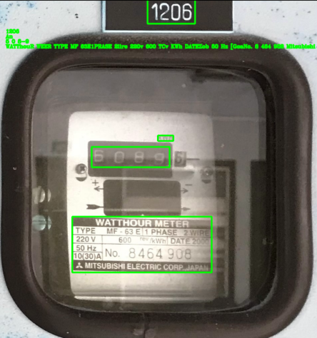D:\Project OCR\Hornai\hornai-50cm-1206.jpg

[[[[444, 0], [586, 0], [586, 72], [444, 72]], '1206'], [[[475, 407], [521, 407], [521, 423], [475, 423]], 'An'], [[[277, 441], [510, 441], [510, 502], [277, 502]], '5 0 8-9'], [[[219, 650], [636, 650], [636, 817], [219, 817]], 'WATThouR WEER TYPE MF 63E1PRASE 2iire 220v 600 TCv KWh DATEZob 50 Hz [GoaNo. 8 464 908 Mitsubishi Electric corp Japan']]

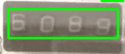

*มีReflex จนอ่านค่าเพี้ยน

D:\Project OCR\Hornai\hornai-50cm-1207.jpg

[[[[371, 14], [523, 14], [523, 91], [371, 91]], '1207'], [[[430, 634], [860, 634], [860, 803], [430, 803]], 'MATTHOURLETER Type Mc D Phase ZTE 220V 600 Gln DE 200] 50 Mz No; 8465 023 1M20A KnsubkhEEcTrCCON? Japan']]

D:\Project OCR\Hornai\hornai-50cm-1208.jpg

[[[[346, 22], [496, 22], [496, 100], [346, 100]], '1208'], [[[586, 380], [640, 380], [640, 404], [586, 404]], 'kWh'], [[[390, 430], [564, 430], [564, 480], [390, 480]], '6 9 6'], [[[324, 642], [752, 642], [752, 808], [324, 808]], 'WATtHOUR METER IPE MF 63EPHASE 2Wire 220V 600 TerKun DAIE 2000 S0 Hz No; 8465 022 D300 Mitsubishi ElectrIC corP JAPAI']]

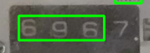

D:\Project OCR\Hornai\hornai-50cm-1209.jpg

[[[[422, 10], [574, 10], [574, 88], [422, 88]], '1209'], [[[502, 378], [558, 378], [558, 402], [502, 402]], 'kwh'], [[[229, 642], [660, 642], [660, 810], [229, 810]], 'WATTHOUR METER IYPE MF 63El1 PHASE 220V 600 rOvkw DATE 50 Hz MToANo 8 464 905 Mitsubishi ElectrIC Corp_Jaran']]

D:\Project OCR\Hornai\hornai-50cm-1210.jpg

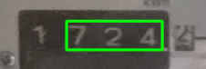[[[[382, 12], [523, 12], [523, 92], [382, 92]], '1210'], [[[450, 428], [616, 428], [616, 478], [450, 478]], '7 2 4'], [[[322, 637], [742, 637], [742, 796], [322, 796]], 'MTHOURLEER iE CF EEIEAAI 2i 24 ED DAi b167 N 3404#07 KOC Ooesoerctrccoar aaaay']]

D:\Project OCR\Hornai\hornai-50cm-1211.jpg

[[[[404, 16], [528, 16], [528, 92], [404, 92]], '1211'], [[[235, 625], [650, 625], [650, 784], [235, 784]], 'WHouR MetER IPE MF B3E4PHASE ZLEE 2207 600 EAhDABE29 b+ EQaNo 8465 052 Ansub HeecIRIC Corp Japah']]

D:\Project OCR\Hornai\hornai-50cm-1212.jpg

[[[[404, 0], [536, 0], [536, 74], [404, 74]], '1212'], [[[140, 619], [489, 619], [489, 772], [140, 772]], 'MTTHOUANEER TTPE Vf DJEJLSE 220 DATA 13 HDA ` 840304 Mitsubismi ELECTIA Ga']]

D:\Project OCR\Hornai\hornai-50cm-1213.jpg

[[[[377, 21], [523, 21], [523, 105], [377, 105]], '1213'], [[[449, 412], [633, 412], [633, 467], [449, 467]], '5 `'], [[[438, 634], [834, 634], [834, 807], [438, 807]], 'FouNEER Heehase Erre 609 Ke 0e " CATE Zo0 No 8393 541 ISCTI07']]

D:\Project OCR\Hornai\hornai-50cm-1214.jpg

[[[[460, 16], [604, 16], [604, 96], [460, 96]], '1214'], [[[582, 364], [638, 364], [638, 388], [582, 388]], 'kWh'], [[[376, 411], [487, 411], [487, 462], [376, 462]], '3 0'], [[[310, 633], [756, 633], [756, 805], [310, 805]], 'WATTHOUR METER INPE MF 5* BPHASE 2WIRE 220V 600 rer Ikun DATE 2000 50 Hz LCOANo 8 393 540 Intsubiski electric corp JapaN']]

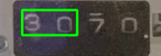

D:\Project OCR\Hornai\hornai-50cm-1215.jpg

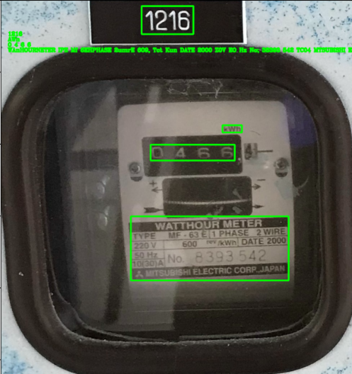[[[[503, 21], [655, 21], [655, 107], [503, 107]], '1215'], [[[518, 382], [576, 382], [576, 408], [518, 408]], 'kWh'], [[[214, 656], [680, 656], [680, 835], [214, 835]], 'WATTHOURMEER TYPE MF 63 El1 PHA SE 2 WIRE 220V 60u Mev IkWh DATE <000 50 Hz 13O) No. 8 39 3 543 Mitsubishi eLeCtrIC Corp JJARAN']]

D:\Project OCR\Hornai\hornai-50cm-1216.jpg

[[[[392, 18], [536, 18], [536, 96], [392, 96]], '1216'], [[[617, 349], [671, 349], [671, 369], [617, 369]], 'AWn'], [[[417, 403], [651, 403], [651, 447], [417, 447]], '0 4 6 6'], [[[362, 602], [801, 602], [801, 780], [362, 780]], 'WAnHOURNETER IPE Mf 6EHPHASE 2umrE 609, Tct Kun DATE 2000 Z0V EO Hz No; 38393 542 TC04 MTSUBISHI ELEcIRIC corr JAPAN']]

D:\Project OCR\Hornai\hornai-50cm-1217.jpg

[[[[434, 14], [570, 14], [570, 92], [434, 92]], '1217'], [[[502, 348], [554, 348], [554, 372], [502, 372]], 'kWh'], [[[302, 399], [471, 399], [471, 445], [302, 445]], '5 7 0'], [[[244, 600], [658, 600], [658, 760], [244, 760]], 'WATtHOUR WETER IYPE ME 63E1PHASE 2wire 520V 600 Tet/kWn DATE 2000 Hz No; 8465 788 0A Mitsubishi eLectaIC Coap Iam']]

D:\Project OCR\Hornai\hornai-50cm-1218.jpg

[[[[484, 14], [620, 14], [620, 92], [484, 92]], '1218'], [[[245, 395], [289, 395], [289, 439], [245, 439]], '2'], [[[160, 593], [568, 593], [568, 751], [160, 751]], "WTTHOURMMEUER TYPE NF 67 E,' Phase Kes 220 6.I m 50 Hz 3c ctl[86 D84 Mit subishi ElectaicTOn"]]

**หอในชั้น 3 ระยะ 50 cm**

D:\Project OCR\Hornai\hornai-50cm-1301.jpg

[[[[380, 8], [510, 8], [510, 80], [380, 80]], '1301'], [[[379, 484], [545, 484], [545, 532], [379, 532]], '3 7 6'], [[[318, 681], [727, 681], [727, 850], [318, 850]], 'DAHHOURMETER Tpe ME 63 EhPHASE_2WRE EJV ELD ThTDATE 2000 Bhz No 8464 902 LCOA DsveshuelectaI coap_JAPAN']]

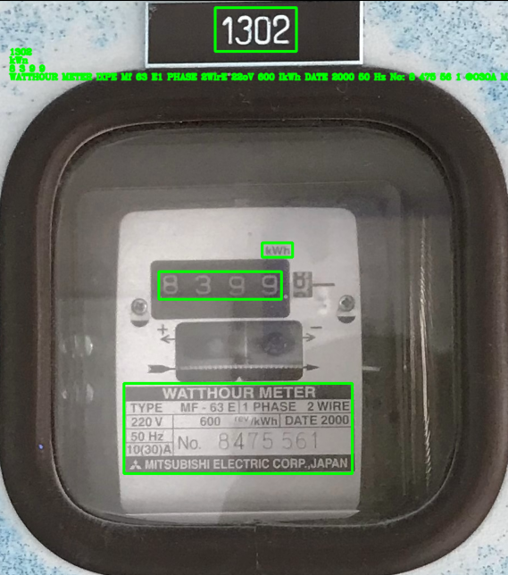

D:\Project OCR\Hornai\hornai-50cm-1302.jpg

[[[[392, 15], [539, 15], [539, 94], [392, 94]], '1302'], [[[477, 440], [532, 440], [532, 466], [477, 466]], 'kWn'], [[[290, 492], [512, 492], [512, 542], [290, 542]], '8 3 9 9'], [[[227, 694], [640, 694], [640, 857], [227, 857]], 'WATTHOUR METER IXPE Mf 63 E1 PHASE 2WIrE 22oV 600 IkWh DATE 2000 50 Hz No: 8 475 56 1 @O3OA Mitsubishi ELECTRIC CoRP JAPAN']]

D:\Project OCR\Hornai\hornai-50cm-1303.jpg

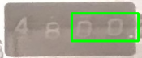[[[[404, 8], [552, 8], [552, 84], [404, 84]], '1303'], [[[356, 500], [490, 500], [490, 556], [356, 556]], '0 0 ,'], [[[176, 710], [606, 710], [606, 872], [176, 872]], 'WATTHOUR METER IYPE MF 63EHPHASE 2MrE 220 V 600 re KWb DATE 2000 50Hz No; 8465 260 10(30A Mitsubishi Electric CorP JAPAN']]

D:\Project OCR\Hornai\hornai-50cm-1304.jpg

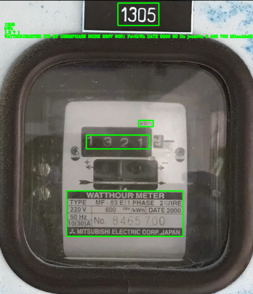[[[[436, 12], [593, 12], [593, 93], [436, 93]], '1304'], [[[653, 471], [703, 471], [703, 489], [653, 489]], 'Rwn'], [[[357, 743], [822, 743], [822, 918], [357, 918]], 'MOURLEER LPE QUEI PHASE 2WirE 220 602 Tev Luh DATE 2000 504 No; 8 465 699 DOCO Unsubishieleciric corp JAPAN']]

D:\Project OCR\Hornai\hornai-50cm-1305.jpg

[[[[455, 13], [612, 13], [612, 98], [455, 98]], '1305'], [[[534, 460], [590, 460], [590, 484], [534, 484]], 'kWh'], [[[334, 516], [576, 516], [576, 569], [334, 569]], '1.3 ? 1'], [[[258, 729], [704, 729], [704, 902], [258, 902]], 'WATTHOURMETER IPE MF G3EMPHASE 25IRE 220V 6001 FevIkWh DATE 2000 50 Hz jcoaNo; 8 465 700 MitsubisHI Electric CorP_JAPAN']]

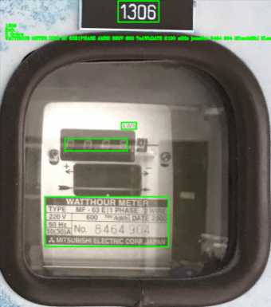D:\Project OCR\Hornai\hornai-50cm-1306.jpg

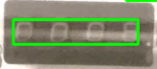[[[[424, 6], [570, 6], [570, 82], [424, 82]], '1306'], [[[436, 442], [490, 442], [490, 466], [436, 466]], 'Rwh'], [[[234, 500], [457, 500], [457, 544], [234, 544]], '0 Orore'], [[[162, 708], [604, 708], [604, 887], [162, 887]], 'WATTHOUR METER IXPE Mf 63E1PHASE AMRE 220V 600 TeAWhDATE 2100 s0Hz jcoaNo: 8464 904 MitsubiShI ELectaIC CORP NAPN']]

D:\Project OCR\Hornai\hornai-50cm-1307.jpg

[[[[357, 18], [512, 18], [512, 103], [357, 103]], '1307'], [[[428, 424], [486, 424], [486, 472], [428, 472]], 'G'], [[[370, 629], [797, 629], [797, 808], [370, 808]], 'mnthour MMETER MPE Mf BTEnPHASE rE {DV 600} Awn DaTE 2000 60d No 8464 968 IODA Dntvaishelectriocorp Japan']]

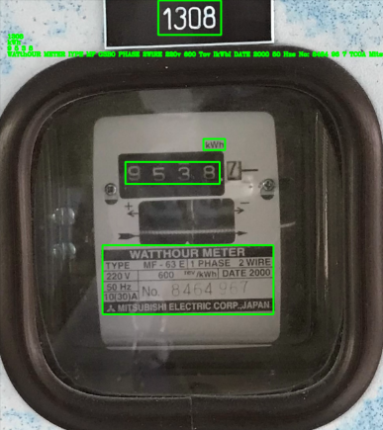

D:\Project OCR\Hornai\hornai-50cm-1308.jpg

[[[[401, 4], [560, 4], [560, 91], [401, 91]], '1308'], [[[515, 354], [570, 354], [570, 382], [515, 382]], 'kWh'], [[[318, 412], [556, 412], [556, 468], [318, 468]], '9 5 3 8'], [[[260, 623], [692, 623], [692, 797], [260, 797]], 'WATthOUR METER IYPE MF G3B0 PHASE 2WiRE 220v 600 Tov IkWbI DATE 2000 50 Hze No: 8464 96 7 TCOA Mitsubiski ElectRIC CorP JAPAN']]

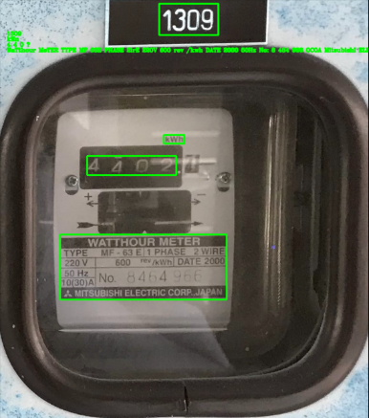D:\Project OCR\Hornai\hornai-50cm-1309.jpg

[[[[437, 13], [599, 13], [599, 99], [437, 99]], '1309'], [[[450, 372], [506, 372], [506, 396], [450, 396]], 'kWn'], [[[240, 430], [484, 430], [484, 482], [240, 482]], '4 4 0 ?'], [[[166, 645], [622, 645], [622, 823], [166, 823]], 'WaTthour MeTER TYPE MF 63E PHASE 2irE 220V 600 rev /kwh DATE 2000 50Hz No: 8 464 966 OCOA MitsubishI ELECTaIC CORP JAPAN']]

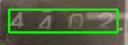

*อ่านค่าเพี้ยนจาก 2 เป็น ?

D:\Project OCR\Hornai\hornai-50cm-1310.jpg

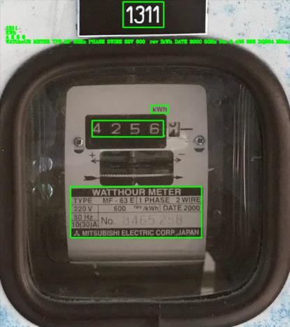[[[[399, 16], [544, 16], [544, 96], [399, 96]], '1310'], [[[420, 414], [676, 414], [676, 468], [420, 468]], '5 3 0F5i'], [[[362, 625], [799, 625], [799, 803], [362, 803]], 'RATTHOURMETER TYPE MF 63E4 PHASE EiaQ 2E0V 600 e kwn DATE 2000 S0d No 8465 697 1OcdA Mtsubishiclectric corp JapAN']]

D:\Project OCR\Hornai\hornai-50cm-1311.jpg

[[[[407, 9], [541, 9], [541, 93], [407, 93]], '1311'], [[[500, 350], [556, 350], [556, 376], [500, 376]], 'KWh'], [[[305, 400], [540, 400], [540, 454], [305, 454]], '4 2 5 6'], [[[234, 618], [666, 618], [666, 786], [234, 786]], 'WATthoUR METER YPE MF 63En PHASE 2WIRE 22V 600 rev IkWh DATE 2000 50Hz No: 8 465 258 DQ604 Mitsubishi ELecTaIC CorP_JAPAN']]

D:\Project OCR\Hornai\hornai-50cm-1312.jpg

[[[[463, 19], [609, 19], [609, 103], [463, 103]], '1312'], [[[465, 359], [517, 359], [517, 379], [465, 379]], 'Kwh'], [[[182, 626], [624, 626], [624, 805], [182, 805]], 'WHHOUAMETER IYPE MF 6 EPHASE 2WIRE; 220 V RoO Ttd ~kwn DATE 240g 50 Hz No; 8 405 698 TQOa Mitsubishi ELECTRIC CORR JAPAN']]

D:\Project OCR\Hornai\hornai-50cm-1313.jpg

[[[[354, 14], [488, 14], [488, 90], [354, 90]], '1313'], [[[537, 333], [587, 333], [587, 353], [537, 353]], 'Awn'], [[[415, 381], [575, 381], [575, 425], [415, 425]], '3 8 9'], [[[287, 580], [692, 580], [692, 736], [287, 736]], 'MATTHOUR METER FHFE KF 63B4PHASE 2aE ZDV 600 LunIDATE 2000 H No; 8465 239 10OOE Wisubishielectric corp JAPAN']]

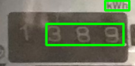

D:\Project OCR\Hornai\hornai-50cm-1314.jpg

[[[[392, 22], [520, 22], [520, 94], [392, 94]], '1314'], [[[477, 353], [525, 353], [525, 373], [477, 373]], 'kWh'], [[[294, 394], [462, 394], [462, 446], [294, 446]], '7 9 1'], [[[231, 596], [628, 596], [628, 750], [231, 750]], "WATTHOUR METER TYPE MF 63 BL PHASE 2 Wire 220V 600 TCv IkWh[ DATE 2000 S0Hz @CoANo: 8475 5',3 MitSubISHI ELectrIC CORP JAPAN"]]

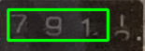

D:\Project OCR\Hornai\hornai-50cm-1315.jpg

[[[[394, 16], [526, 16], [526, 90], [394, 90]], '1315'], [[[381, 347], [431, 347], [431, 367], [381, 367]], 'kWh'], [[[309, 390], [411, 390], [411, 441], [309, 441]], '7 3'], [[[123, 591], [532, 591], [532, 753], [123, 753]], 'WATTHOUR METER TPE MR 62ELPHASE 2irb 220v 600 rev IWh DATE 2000 S0Hz @@COANo: 8465 25 ( Mitsubishi Electric corP JAPAN']]

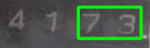

D:\Project OCR\Hornai\hornai-50cm-1316.jpg

[[[[372, 20], [506, 20], [506, 94], [372, 94]], '1316'], [[[574, 360], [626, 360], [626, 384], [574, 384]], 'KWh'], [[[322, 608], [734, 608], [734, 771], [322, 771]], 'MATHOUR METER Ie DF 63e Phase 2WrE 220 V 602 Mhln[DATE 2000 Soz 70,30 No; " nsubiShi electric Corp_JAPAN']]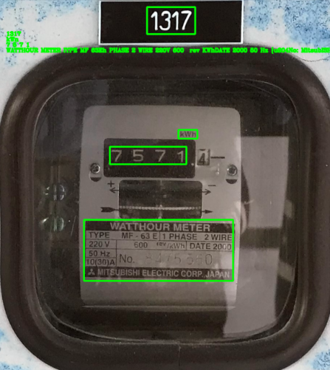

D:\Project OCR\Hornai\hornai-50cm-1317.jpg

[[[[406, 22], [538, 22], [538, 96], [406, 96]], '1317'], [[[492, 358], [544, 358], [544, 382], [492, 382]], 'kWn'], [[[304, 404], [514, 404], [514, 452], [304, 452]], '7 5 7 1'], [[[233, 604], [642, 604], [642, 771], [233, 771]], 'WATTHOUR METER IYPE MF 63Eh PHASE 2 WIRE 220V 600 rev KWhDATE 2000 50 Hz {u804No: MitsubISHI ELeCTRIC CORP JAPAN']]

D:\Project OCR\Hornai\hornai-50cm-1318.jpg

[[[[434, 2], [568, 2], [568, 78], [434, 78]], '1318'], [[[468, 336], [522, 336], [522, 360], [468, 360]], 'kwh'], [[[269, 389], [445, 389], [445, 433], [269, 433]], '9 4 5'], [[[198, 594], [618, 594], [618, 754], [198, 754]], 'WaTthQur MeTER LLPE MF 63 Eh PHASE wial 220V 600 Lwn DALE 2001 50Hz Joa No: 8464 4 5 Mitsubishi electRIC coar Jadan']]

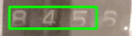

**หอในชั้น 4 ระยะ 50 cm**

D:\Project OCR\Hornai\hornai-50cm-1401.jpg

[[[[343, 9], [461, 9], [461, 73], [343, 73]], '1401'], [[[328, 628], [582, 628], [582, 657], [328, 657]], 'VLINOALLTA'], [[[290, 676], [599, 676], [599, 770], [290, 770]], 'At Ho 8465 1 15 WuAALLAccl Ja']]

D:\Project OCR\Hornai\hornai-50cm-1402.jpg

[[[[376, 15], [517, 15], [517, 91], [376, 91]], '1402'], [[[319, 475], [472, 475], [472, 524], [319, 524]], '3 7 3'], [[[262, 662], [530, 662], [530, 694], [262, 694]], 'VLHHHOUHLALUS'], [[[285, 713], [529, 713], [529, 783], [285, 783]], '6at No. 8464901'], [[[230, 782], [572, 782], [572, 810], [230, 810]], 'MIbLMLLLSAccolrJadaml']]

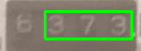

D:\Project OCR\Hornai\hornai-50cm-1403.jpg

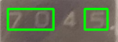[[[[392, 15], [535, 15], [535, 93], [392, 93]], '1403'], [[[189, 475], [285, 475], [285, 519], [189, 519]], '7.0'], [[[351, 475], [399, 475], [399, 519], [351, 519]], 'I;'], [[[281, 734], [482, 734], [482, 786], [281, 786]], '847']]

D:\Project OCR\Hornai\hornai-50cm-1404.jpg

[[[[426, 24], [576, 24], [576, 101], [426, 101]], '1404'], [[[332, 728], [688, 728], [688, 905], [332, 905]], 'Mtlouua Dn Na 0464.6 MLETDNECON']]

D:\Project OCR\Hornai\hornai-50cm-1405.jpg

[[[[440, 22], [590, 22], [590, 100], [440, 100]], '1405'], [[[321, 511], [490, 511], [490, 564], [321, 564]], '8 9 R'], [[[283, 722], [682, 722], [682, 899], [283, 899]], 'WAHOURMEUNA Ail HMpmS Wire Ron (Walna Fm No 8303 343 MlsudimicuQircgora JARN']]

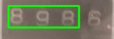

D:\Project OCR\Hornai\hornai-50cm-1406.jpg

[[[[464, 8], [614, 8], [614, 86], [464, 86]], '1406'], [[[266, 490], [565, 490], [565, 567], [266, 567]], '5 0.9 6 b'], [[[270, 713], [574, 713], [574, 890], [270, 890]], 'MT@hEu 6 h No 3414876 TrdEkcOn']]

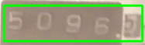

D:\Project OCR\Hornai\hornai-50cm-1407.jpg

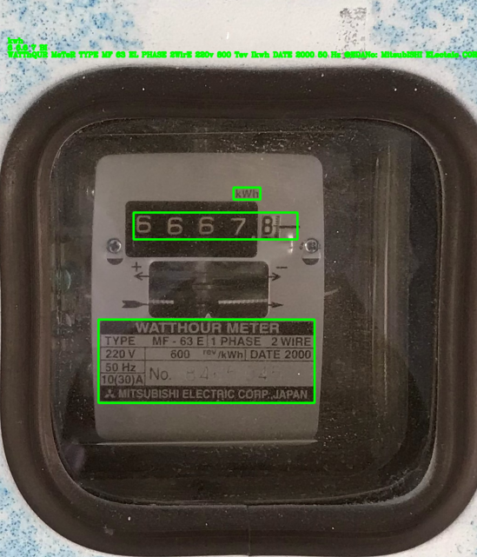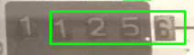[[[[399, 27], [565, 27], [565, 113], [399, 113]], '1407'], [[[636, 416], [694, 416], [694, 442], [636, 442]], 'kWh'], [[[489, 467], [762, 467], [762, 534], [489, 534]], '172 5,'], [[[360, 706], [828, 706], [828, 886], [360, 886]], 'WATthOUR METER TYPE MF 63E/1PHASE 2WIRE 220M 600 rev /kWhIDATE 2000 S0Hz No. 8465 1 1 3 IOOQA Mitsubishi ElectrIC corP_JAPAN']]

D:\Project OCR\Hornai\hornai-50cm-1408.jpg

[[[[508, 412], [566, 412], [566, 438], [508, 438]], 'kwh'], [[[292, 466], [646, 466], [646, 524], [292, 524]], '6 6.6 7 BI'], [[[216, 697], [683, 697], [683, 877], [216, 877]], 'WATThQUR MeTeR TYPE MF 63 EL PHASE 2WirE 220v 800 Tev Ikwh DATE 2000 50 Hz @EDANo: MitsubISHI ELectaic CORP JAPAN']]

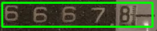

D:\Project OCR\Hornai\hornai-50cm-1409.jpg

[[[[493, 25], [659, 25], [659, 111], [493, 111]], '1409'], [[[422, 402], [478, 402], [478, 426], [422, 426]], 'kwh'], [[[263, 453], [562, 453], [562, 516], [263, 516]], '5 1 3 H_'], [[[112, 683], [576, 683], [576, 869], [112, 869]], 'WATTHOUR METER IYPE MF 63 Eh PHASE 2WIRE 220V 600 rev KWhDDATE 2000 50 Hz icoANo: 8 475 51 7 MITSUBISHI ELECTRIC CORP JJAPAN']]

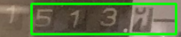

D:\Project OCR\Hornai\hornai-50cm-1410.jpg

[[[[496, 16], [626, 16], [626, 92], [496, 92]], '1410'], [[[122, 599], [479, 599], [479, 766], [122, 766]], 'WAIHOURLEVER TYPE M DDESE 220 ! 660 72 -nn DATE 5042 N 8464 35 1 doc0 A MitsubrsneecTaCcorp']]

D:\Project OCR\Hornai\hornai-50cm-1411.jpg

[[[[499, 21], [635, 21], [635, 105], [499, 105]], '1411'], [[[560, 360], [614, 360], [614, 384], [560, 384]], 'kWh'], [[[419, 421], [487, 421], [487, 461], [419, 461]], '4;'], [[[272, 631], [714, 631], [714, 801], [272, 801]], 'WaIhouR MeteR IYPE ME - 63 E1PHASE 2wiae] 220V 600 Clw DATE2000] LS0 Hz No; 8 465 046 JO(30A KitsubisrI ElecTrIC CorP JAPATI']]

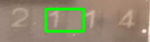

D:\Project OCR\Hornai\hornai-50cm-1412.jpg

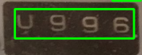[[[[477, 11], [643, 11], [643, 98], [477, 98]], '1412'], [[[718, 388], [782, 388], [782, 412], [718, 412]], 'Kwn'], [[[497, 431], [767, 431], [767, 498], [497, 498]], 'U 9 9 6'], [[[419, 672], [914, 672], [914, 855], [419, 855]], 'WATHOUR METER HNPE KF 63E LPHASE ZuRa 2208 500 (Bvavn Dale200 31 4z DOENo Wnsdbkhielectric corp_Japai']]

D:\Project OCR\Hornai\hornai-50cm-1413.jpg

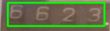[[[[505, 20], [662, 20], [662, 110], [505, 110]], '1413'], [[[444, 436], [502, 436], [502, 462], [444, 462]], 'KWh'], [[[225, 487], [475, 487], [475, 548], [225, 548]], '6 6 2*3'], [[[135, 719], [600, 719], [600, 894], [135, 894]], 'WATTHouR MeTER IYPE MF 63El1 PHASE 2WIRE 220V 600 rev KWh]DATE 2000 50 Hz HOGOANo. 8 465 1 55 MitSUbISHI ELeCTRIC CorP_JAPAN']]

D:\Project OCR\Hornai\hornai-50cm-1414.jpg

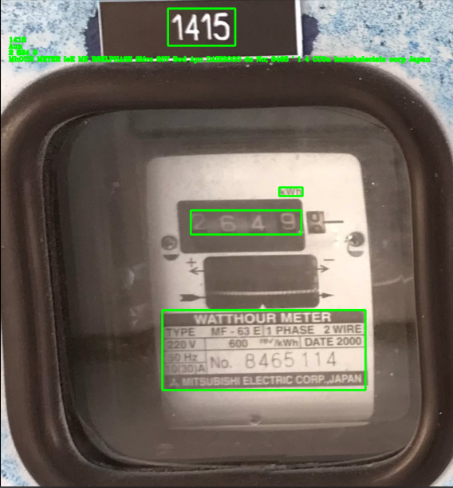[[[[441, 21], [593, 21], [593, 106], [441, 106]], '1414'], [[[530, 424], [590, 424], [590, 448], [530, 448]], 'Lwh'], [[[386, 482], [561, 482], [561, 532], [386, 532]], "7 6 '7"], [[[256, 705], [712, 705], [712, 885], [256, 885]], 'WATTHOUR METER IYBE MF 63EHPHASE ZWRE 220_ 600 Tev ikWbI DBIE 2000 s0Hz No: L" JOCOA Mnsubishi ElecTRIC CoRP,Japati:']]

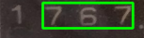

D:\Project OCR\Hornai\hornai-50cm-1415.jpg

[[[[389, 23], [545, 23], [545, 109], [389, 109]], '1415'], [[[647, 437], [701, 437], [701, 457], [647, 457]], 'Aun'], [[[442, 490], [698, 490], [698, 546], [442, 546]], '2 624 9'], [[[376, 721], [847, 721], [847, 906], [376, 906]], "MhOUR METER IeE ME B3ELPHASE 2Mre 20V Bod Ayn DAIE2OOO dz No; 8465 ' 1 4 CCOa Isubsheleciaic corp Japan"]]

D:\Project OCR\Hornai\hornai-50cm-1416.jpg

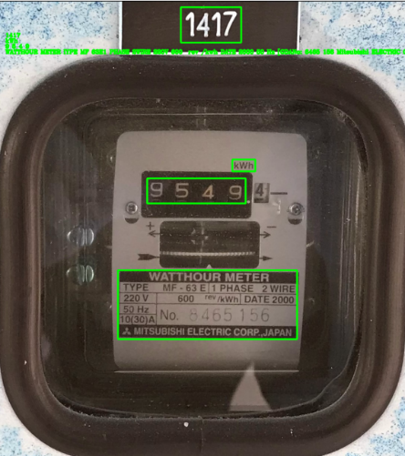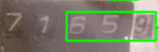[[[[526, 23], [682, 23], [682, 110], [526, 110]], '1416'], [[[470, 430], [532, 430], [532, 458], [470, 458]], 'kWh'], [[[377, 485], [569, 485], [569, 547], [377, 547]], '6 5,191'], [[[144, 725], [627, 725], [627, 913], [144, 913]], 'WATTHOUR METER IYPE MF 63 ELLPHASE 2WIREA 220V 600 Tev IkWhDDATE 2006 50 Hz joANo 8465 336 MITSUBISHI ELECTRIC CORP JAPAN']]

D:\Project OCR\Hornai\hornai-50cm-1417.jpg

[[[[494, 19], [657, 19], [657, 115], [494, 115]], '1417'], [[[633, 432], [695, 432], [695, 464], [633, 464]], 'kWh'], [[[403, 483], [669, 483], [669, 551], [403, 551]], '9 5 4 9'], [[[324, 732], [808, 732], [808, 919], [324, 919]], 'WATTHOUR METER IYPE MF 63E1 PHASE 2WIRE 220V 600 rev /kwh DATE 2000 50 Hz [GDANo: 6465 156 Mitsubishi ELECTRIC CORP JAPAN']]

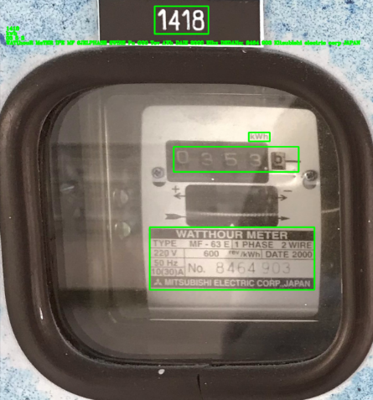D:\Project OCR\Hornai\hornai-50cm-1418.jpg

[[[[473, 25], [637, 25], [637, 112], [473, 112]], '1418'], [[[760, 422], [824, 422], [824, 450], [760, 450]], 'kwh'], [[[531, 467], [912, 467], [912, 546], [531, 546]], '03 5 3 '], [[[458, 720], [960, 720], [960, 917], [458, 917]], 'WATthouR MeTER IPE MF 6JELPHASE 2WIRE Fu G00 Tev AWh DAIE 2000 Elhz DEDANo; 8464 903 Kitsubishi electric corp JAPAN']]

**หอในชั้น 5 ระยะ 50 cm**

D:\Project OCR\Hornai\hornai-50cm-1501.jpg

[[[[297, 21], [413, 21], [413, 85], [297, 85]], '1501'], [[[374, 460], [521, 460], [521, 508], [374, 508]], '3 ? 8'], [[[324, 636], [675, 636], [675, 778], [324, 778]], 'EuoUaMEEa CPE Vr S3 IPrd€ WfE Ezov 6o0 DATE FokE No 6465429 Mcok Eansubismcuectaiccordua']]

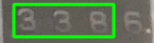

D:\Project OCR\Hornai\hornai-50cm-1502.jpg

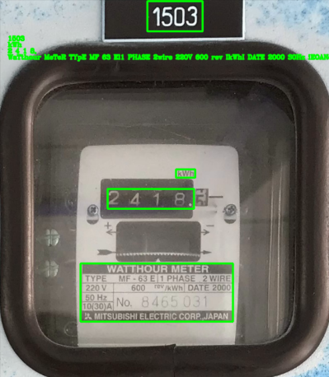[[[[333, 17], [457, 17], [457, 81], [333, 81]], '1502'], [[[471, 419], [515, 419], [515, 435], [471, 435]], 'Kwn'], [[[252, 642], [612, 642], [612, 784], [252, 784]], 'MTTHOURMETER IPE CF 63 EPHASE 2Wire 22V 6c0 ADAIE 2000 shZ No; 8 465 430 OCOOA Osubsh electacc corp Japan']]

D:\Project OCR\Hornai\hornai-50cm-1503.jpg

[[[[356, 5], [489, 5], [489, 78], [356, 78]], '1503'], [[[425, 411], [471, 411], [471, 431], [425, 431]], 'kWh'], [[[260, 458], [468, 458], [468, 506], [260, 506]], '2 4 1 8,'], [[[195, 638], [562, 638], [562, 778], [195, 778]], 'WaTthour MeTeR TYpE MF 63 El1 PHASE 2wire 220V 600 rev IkWhI DATE 2000 S0Hz iEOANo 8 465 0.31 MItsubiSHi ELECTRIC CorP_JAPAN']]

D:\Project OCR\Hornai\hornai-50cm-1504.jpg

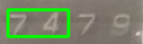 [[[[369, 13], [497, 13], [497, 81], [369, 81]], '1504'], [[[377, 421], [423, 421], [423, 441], [377, 441]], 'kWh'], [[[207, 469], [301, 469], [301, 511], [207, 511]], '7 4'], [[[143, 647], [512, 647], [512, 788], [143, 788]], 'WATthouR WeTER TYPE ME _ 63 ElPHASE 2ire 220 V 600 kWh DATE 2000 50Hz Jo8ozNo 8 465 032 Mitsubish} electric Corp JAPAN']]

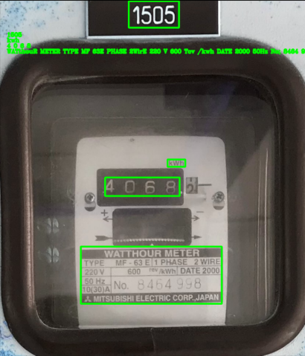

D:\Project OCR\Hornai\hornai-50cm-1505.jpg

[[[[350, 4], [486, 4], [486, 76], [350, 76]], '1505'], [[[455, 433], [503, 433], [503, 453], [455, 453]], 'kwh'], [[[286, 482], [488, 482], [488, 532], [286, 532]], '4 0 6 8'], [[[220, 669], [602, 669], [602, 824], [220, 824]], 'WATthouR METER TYPE MF 63E PHASE 2WirE 220 V 600 Tcv /kwh DATE 2000 50Hz No; 8464 998 HOSQA Mitsubishi ELECTRIC CORP JAPAN']]

D:\Project OCR\Hornai\hornai-50cm-1506.jpg

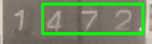[[[[386, 0], [520, 0], [520, 70], [386, 70]], '1506'], [[[363, 435], [409, 435], [409, 455], [363, 455]], 'Kwn'], [[[237, 482], [400, 482], [400, 530], [237, 530]], '4 7 2'], [[[132, 668], [510, 668], [510, 820], [132, 820]], 'WATthoUR METER TYPE ME 63 El PHASE 2wire 220V 600. rev TkWhI DATE 2000 50Hz No; 8 465 000 TOGOA Mitsubishi ELecTrIC CORP JAPAN']]

D:\Project OCR\Hornai\hornai-50cm-1507.jpg

[[[[307, 0], [430, 0], [430, 59], [307, 59]], '1507'], [[[443, 529], [517, 529], [517, 549], [443, 549]], 'ouc']]

D:\Project OCR\Hornai\hornai-50cm-1508.jpg

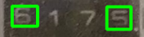[[[[316, 9], [439, 9], [439, 73], [316, 73]], '1508'], [[[294, 282], [334, 282], [334, 314], [294, 314]], '5'], [[[443, 283], [481, 283], [481, 319], [443, 319]], '5'], [[[296, 454], [590, 454], [590, 586], [296, 586]], 'LTHQURLIETER HePKA P | AFe Fmi DAIAA Ko DCCCGT']]

D:\Project OCR\Hornai\hornai-50cm-1509.jpg

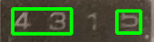[[[[339, 7], [459, 7], [459, 69], [339, 69]], '1509'], [[[403, 253], [445, 253], [445, 269], [403, 269]], 'Kwin'], [[[243, 287], [327, 287], [327, 323], [243, 323]], '4 3'], [[[392, 290], [426, 290], [426, 322], [392, 322]], '9'], [[[183, 462], [537, 462], [537, 596], [183, 596]], "WnHOUR METER Type MF 63 FLPRASE WIaE 26v 6o6 T{' Mwi DRTEF2000 S6h fouaNo; Kitsubishi flcctric coapiapani"]]

D:\Project OCR\Hornai\hornai-50cm-1510.jpg

[[[[327, 9], [445, 9], [445, 71], [327, 71]], '1510'], [[[247, 481], [620, 481], [620, 626], [247, 626]], 'MAIHOURLEETER Ttpe MF DENPHASE 2uirE 2201v 600 RWh DATE 2000 So Hz K Ae [coaNo Citsubishi Electric Corp NJapan']]

D:\Project OCR\Hornai\hornai-50cm-1511.jpg

[[[[343, 7], [451, 7], [451, 71], [343, 71]], '1511'], [[[429, 267], [475, 267], [475, 287], [429, 287]], 'kWh'], [[[261, 311], [297, 311], [297, 347], [261, 347]], '9'], [[[202, 490], [572, 490], [572, 634], [202, 634]], 'WAL thour METER TYPE MF 6J0 PHASE 2 Wire 220V 600 rCv IkWh DATE 2000 50 Hz No; "475 5\'/ 4 nocoa Mitsubishi EleCTRIC corp JAPAN']]

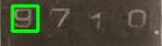

D:\Project OCR\Hornai\hornai-50cm-1512.jpg

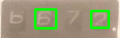[[[[361, 11], [475, 11], [475, 75], [361, 75]], '1512'], [[[363, 273], [407, 273], [407, 293], [363, 293]], 'kwh'], [[[243, 317], [283, 317], [283, 353], [243, 353]], '6'], [[[350, 320], [384, 320], [384, 352], [350, 352]], '4'], [[[129, 496], [502, 496], [502, 638], [129, 638]], 'WATHoUR MeteR TYPE MF 63 EL PHASE Wire 220 V 60u IKWh DATE 2000 B0 Ha Jedoal No; 8 475 572 Mitsubishi electric Coap JAPAN']]

D:\Project OCR\Hornai\hornai-50cm-1513.jpg

[[[[346, 16], [474, 16], [474, 88], [346, 88]], '1513'], [[[355, 379], [511, 379], [511, 421], [355, 421]], '0 5 ?'], [[[353, 563], [693, 563], [693, 721], [353, 721]], 'Mnhour Lbter GJEPASE Wire 6u0 Feen Date 2030 1 62 sue smeleciac corp Jaran']]

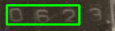

D:\Project OCR\Hornai\hornai-50cm-1514.jpg

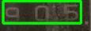[[[[371, 21], [495, 21], [495, 89], [371, 89]], '1514'], [[[481, 331], [529, 331], [529, 351], [481, 351]], 'kWn'], [[[360, 377], [509, 377], [509, 419], [360, 419]], 'a 0 5'], [[[243, 568], [636, 568], [636, 724], [243, 724]], 'WATTHOUR METER IXPE MF 63 Bh RASE @wire 220v "600 iWhIDATE 2000 50 Hz_ [coa No: Mitsubishi ELecTRIC CorP JAPAN']]

D:\Project OCR\Hornai\hornai-50cm-1515.jpg

[[[[153, 13], [267, 13], [267, 77], [153, 77]], '1515'], [[[322, 388], [426, 388], [426, 440], [322, 440]], "6'0"], [[[249, 575], [536, 575], [536, 726], [249, 726]], 'AHOUR LEER PMASE MrE E0o Ar" DATE Z0c0 No Oecctac coapJnpan']]

D:\Project OCR\Hornai\hornai-50cm-1516.jpg

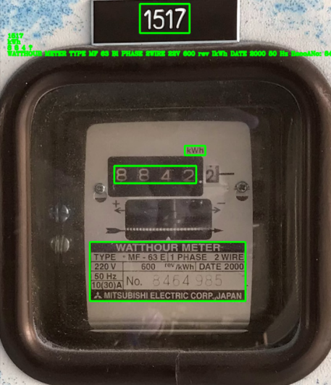[[[[322, 21], [449, 21], [449, 93], [322, 93]], '1516'], [[[501, 377], [547, 377], [547, 397], [501, 397]], 'Kun'], [[[440, 424], [536, 424], [536, 472], [440, 472]], '6 8'], [[[276, 614], [656, 614], [656, 764], [276, 764]], 'MATtHOUR METER TYFE Ha GJEPHASE 2 WiRE 220 v 600 Ter Jatuh DATE2d0d EHz No; 40 { OGCLA Juntsubishi electric Corp_JaPAN']]

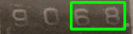

D:\Project OCR\Hornai\hornai-50cm-1517.jpg

[[[[356, 14], [482, 14], [482, 88], [356, 88]], '1517'], [[[470, 374], [522, 374], [522, 398], [470, 398]], 'kWh'], [[[291, 425], [499, 425], [499, 469], [291, 469]], '8 8 4 ?'], [[[229, 618], [624, 618], [624, 768], [229, 768]], 'WATTHOUR METER TYPE MF 63 Bl PHASE 2WIRE 22V 600 rev IkWh DATE 2000 50 Hz liecoANo: 8464 985 Mitsubishi ELECTRIC CORP_JAPAN']]

D:\Project OCR\Hornai\hornai-50cm-1518.jpg

[[[[414, 18], [548, 18], [548, 90], [414, 90]], '1518'], [[[436, 386], [490, 386], [490, 410], [436, 410]], 'kwh'], [[[239, 439], [411, 439], [411, 485], [239, 485]], '2 8 5'], [[[170, 639], [592, 639], [592, 796], [170, 796]], 'Wahour METER TYPE Mf 63 El PHASE 2 Wire 220V 600 rev IkWh]DATE 2000 50Hz No 6464 986 DO(30A MitsubishI ELECTRIC CoRP_JAPAN']]

